PROJECT REPORT

Script-Controlled ACL – Restrict Record Access Based on Field Value

1. INTRODUCTION

1.1 Project Overview
The Script-Controlled ACL – Restrict Record Access Based on Field Value project demonstrates how Access Control Lists (ACLs) can be used in ServiceNow to provide record-level security.
The project creates an Institution Details table containing student information such as Student Roll Number, Student Name, Faculty Name, Branch, Email, Phone Number and Description. Records are created with different branch values such as ECE, EEE and CSE.
The system uses user roles and ACL rules to control access to these records. EEE branch users are allowed to view EEE branch records, while administrators retain full access. Separate ACLs are implemented for Read, Create, Write and Delete operations.

1.2 Purpose
The purpose of this project is to implement a script-controlled ACL mechanism that restricts unauthorized access to Institution Details records.
The project evaluates the user's role and record field values to determine whether access should be allowed or denied. It demonstrates how READ, CREATE, WRITE and DELETE operations can be controlled using separate ACLs.

2. IDEATION PHASE

2.1 Problem Statement
ServiceNow records may contain information that should not be accessible to every user. Without proper record-level access control, unauthorized users may view, create, modify or delete records.
The project addresses the need for controlled access by restricting Institution Details records according to user roles and the Branch field. EEE users should be able to access EEE branch records, while administrators should retain full access.

Customer Problem Statement
- I am: A ServiceNow user accessing Institution Details records.
- I’m trying to: Access only the records I am authorized to view.
- But: Some records should be restricted from unauthorized users.
- Because: Access needs to be controlled based on user roles and the Branch field.
- Which makes me feel: Concerned about unauthorized access to records.

2.2 Empathy Map Canvas

SAYS
- “I should only access the records I am authorized to view.”
- “EEE branch records should be restricted from unauthorized users.”
- “I need secure access to Institution Details records.”

THINKS
- “My records should not be visible to unauthorized users.”
- “Access should depend on my assigned role and the Branch field.”
- “Administrators should have complete access.”

DOES
- Logs in to the ServiceNow instance.
- Opens Institution Details records.
- Attempts to view or perform permitted record operations.

FEELS
- Concerned about unauthorized record access.
- Secure when access is properly controlled.
- Confident when only authorized records are accessible.

PERSONA
Name: ServiceNow User
Role / User Type: Authorized User

2.3 Brainstorming
The project ideas were focused on improving record-level security in ServiceNow.
S.No | Team Member | Idea / Suggestion | Category | Group No.
1 | Team Member 1 | Restrict record access based on user role | Access Control | 1
2 | Team Member 2 | Allow only EEE users to view EEE records | Record Security | 1
3 | Team Member 3 | Use ACL script to control record access and Create, Read, Write and Delete operations | Script Control and CRUD Security | 1
4 | Team Member 4 | Provide administrators with full access  Use Branch field to restrict record visibility | Admin and Field based Security | 1

Idea Prioritization

Rate each grouped idea on feasibility and importance, then select the final idea(s) to move forward with.

Group No. | Final Idea | Feasibility  (High/  Medium/Low) | Importance  (High/  Medium/Low) | Priority Selected  (Yes/No)
1 | Implement Script-Controlled ACL for role and branch-based record access | High | High | Yes
1 | Control READ, CREATE, WRITE and DELETE operations using separate ACLs | High | High | Yes
1 | Restrict EEE branch records and provide admin full access | High | High | Yes

3. REQUIREMENT ANALYSIS

3.1 Customer Journey Map

Phase of Journey
Stage 1 – Login & Access
Stage 2 – Open Institution Details & ACL Check
Stage 3 – View / Perform Authorized Operation

Actions
Stage 1
- Logs in to ServiceNow.
- Accesses the application.
Stage 2
- Opens Institution Details.
- Selects or searches for records.
- Attempts to access a record.
Stage 3
- Views permitted records.
- Creates, edits or deletes records according to assigned roles.

Touchpoint
- ServiceNow Login
- Institution Details table
- Record list and form
- ACL security check
- New, Edit and Delete options

Customer Thought
- “I need to access the Institution Details records.”
- “Am I authorized to access this record?”
- “My operations should depend on my assigned role.”

Customer Feeling
- Expecting secure access.
- Concerned about unauthorized access.
- Confident when access is properly controlled.

Process Ownership
- ServiceNow
- System Administrator
- ACL configuration

Opportunities
- Restrict records based on role and Branch.
- Allow administrators full access.
- Apply separate ACLs for Read, Create, Write and Delete.

3.2 Solution Requirement
The system requires a custom Institution Details table named u_institution_details. The table contains Student Roll Number, Student Name, Faculty Name, Branch, Email, Phone Number and Description fields.
The system also requires the following custom roles:
- bb1 – Read access
- bb2 – Create access
- bb3 – Write access
- bb4 – Delete access
All four roles are assigned to the EEE User for testing.
The ACL requirements are:
- Read ACL: Branch must be EEE and the user requires bb1; administrators retain access.
- Create ACL: User requires bb2.
- Write ACL: User requires bb3.
- Delete ACL: User requires bb4.

3.3 Data Flow Diagram
The Data Flow Diagram represents the movement of data between the ServiceNow user, authentication process, role and Branch validation, ACL evaluation, and the Institution Details data store.

Main Flow
ServiceNow User → Authenticate User → Validate Role & Branch → Evaluate ACL Rules → Institution Details → Control Record Access → ServiceNow User

Data Flow
- Login Credentials
- User Role + Branch
- ACL Request
- Record Data
- Access Result – Allow / Deny
3.4 Technology Stack
The project specifically uses the ServiceNow ACL mechanism, custom roles and the u_institution_details table.

Technology / Component | Purpose
ServiceNow | Platform used to implement and test the ACL system
Access Control List (ACL) | Controls record-level access
ServiceNow Custom Table | Stores Institution Details records
ServiceNow Roles | Controls user permissions
ACL Script | Evaluates user role and access conditions
Institution Details Table | Stores student and branch-related records

4. PROJECT DESIGN

4.1 Problem Solution Fit
The project directly addresses the problem of unauthorized record access by combining user roles, Branch values and ACL rules.
The Read ACL allows EEE branch users to view EEE records, while users without the required role are denied access. Administrators can view all records regardless of Branch.

4.2 Proposed Solution
The proposed solution is to implement separate ACLs for the four major record operations:
READ → CREATE → WRITE → DELETE
The Read ACL uses a script to check whether the user is an administrator or has the required role. The Create, Write and Delete operations are controlled through their respective ACL roles.
This provides controlled record-level access and prevents unauthorized users from performing restricted operations.

4.3 Solution Architecture
The solution architecture illustrates how the ServiceNow user interacts with the Institution Details table through role-based and script-controlled ACLs. The system validates the user's role and Branch value before allowing or denying access to records. Separate ACLs control Read, Create, Write and Delete operations, while administrators retain full access.

ServiceNow User
↓
User Authentication
↓
Role + Branch Validation
↓
Script-Controlled ACL
↓
ACL Evaluation
↓
READ / CREATE / WRITE / DELETE
↓
Institution Details Table
↓
Access Decision
↓
Allow / Deny

5. PROJECT PLANNING & SCHEDULING

Project Planning
Plan and organize the Script-Controlled ACL project by dividing the work into manageable tasks and sprints.

Sprint | Task | Story Points
Sprint-1 | User, Role, Table and Record Creation | 5
Sprint-2 | READ and CREATE ACL Configuration | 5
Sprint-3 | WRITE and DELETE ACL Configuration | 4
Sprint-4 | Verification and Testing | 3

Total Story Points : 17
Number of Sprints : 4
Duration : 9 Days

Project Outcome
The project implements script-controlled ACLs to control READ, CREATE, WRITE, and DELETE access to Institution Details records based on user roles and Branch values

6. FUNCTIONAL AND PERFORMANCE TESTING

6.1 Performance Testing
Functional Testing
Test Case | Test Scenario | Expected Result
FT-01 | User with bb1 accesses Institution Details | Only EEE branch records are visible
FT-02 | User without required role accesses records | Records are not accessible
FT-03 | Administrator accesses Institution Details | All records are visible
FT-04 | User with bb1 and bb2 checks Create access | New button is available
FT-05 | User with bb1, bb2 and bb3 edits an EEE record | EEE record can be edited
FT-06 | User with bb1, bb2, bb3 and bb4 deletes an EEE record | EEE record can be deleted

These expected behaviors are based on the project verification steps

Performance Testing

Test Case | Performance Scenario | Expected Result
PT-01 | Measure ACL evaluation while opening records | Access evaluation should complete without noticeable delay
PT-02 | Test access using multiple users | ACL rules should continue to be applied correctly
PT-03 | Access multiple Institution Details records | Records should load successfully while maintaining access restrictions

Actual response times and Pass/Fail results should be entered after executing the tests.

7. RESULTS

7.1 Output Screenshots of Milestone 1

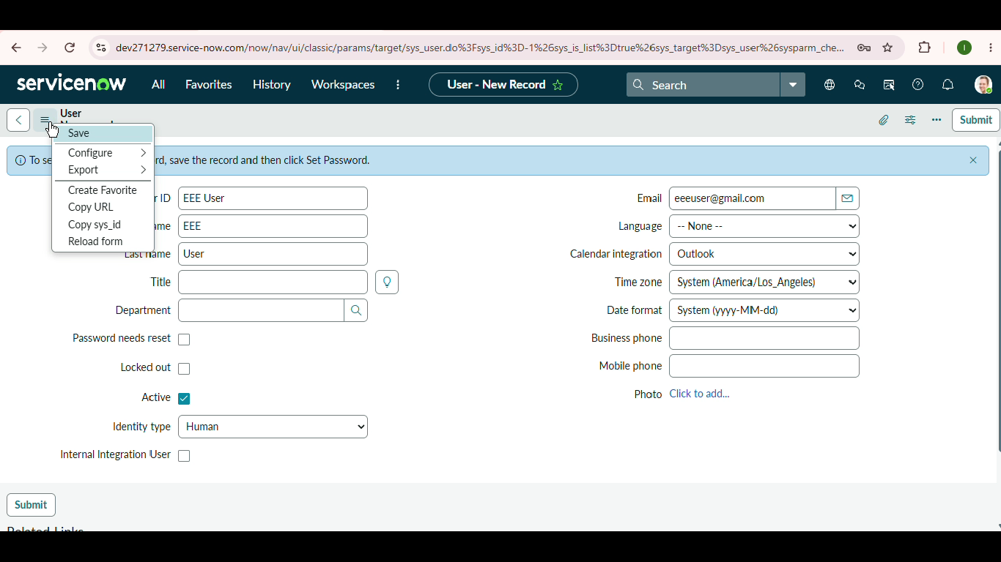

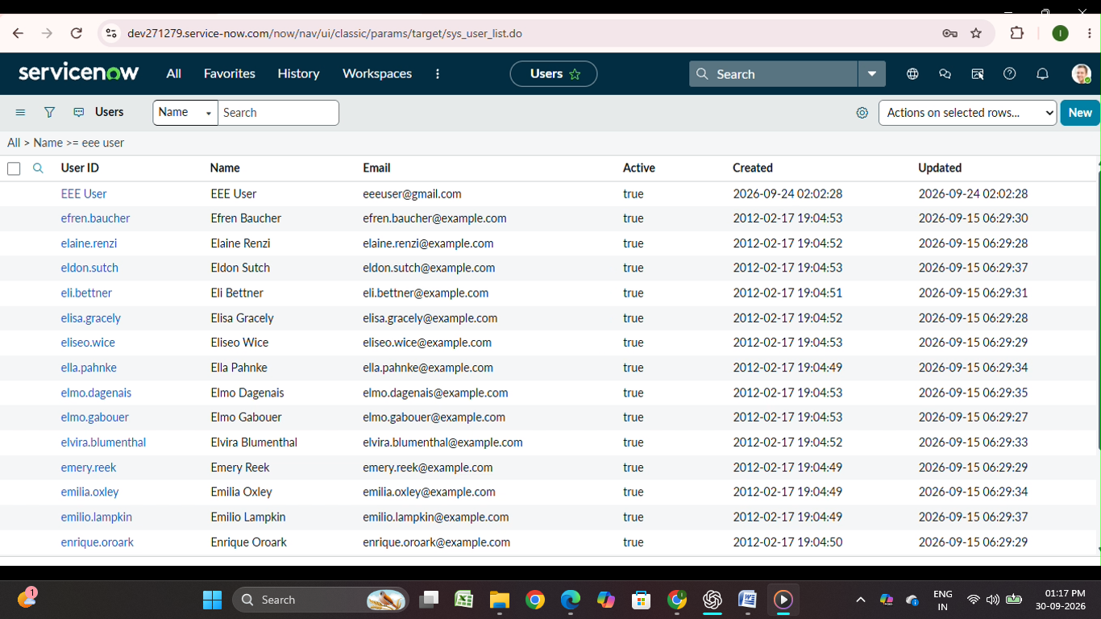

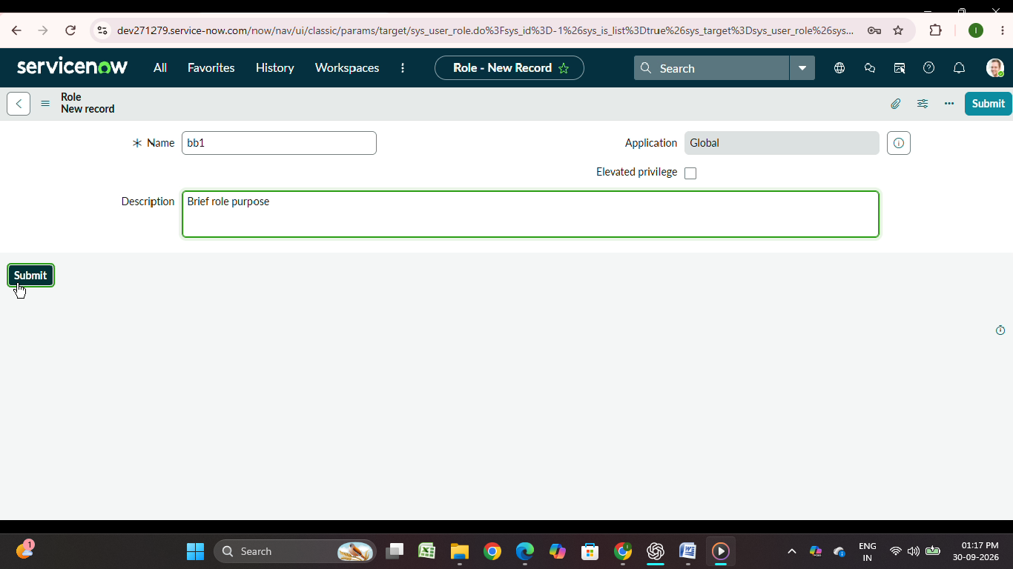

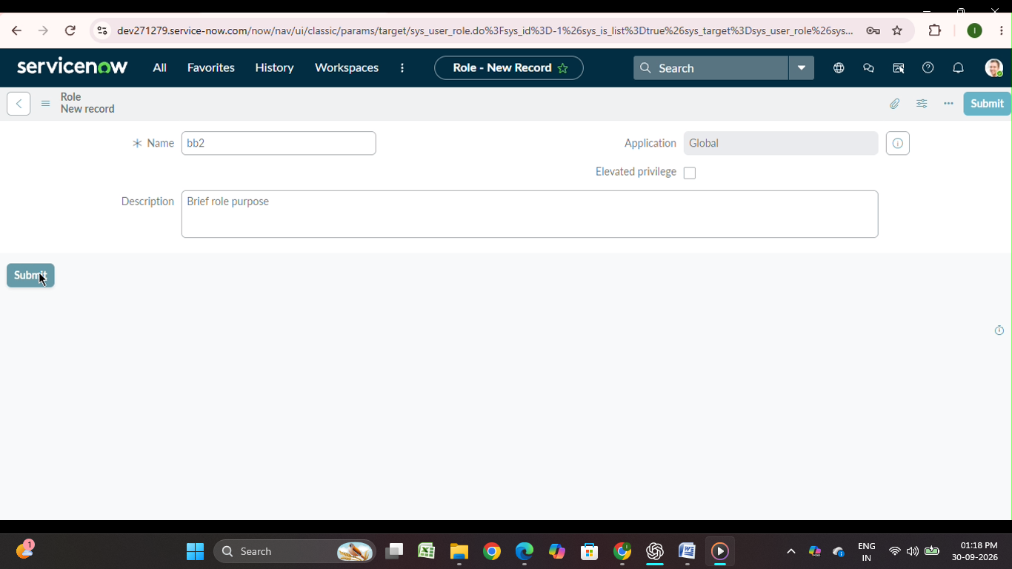

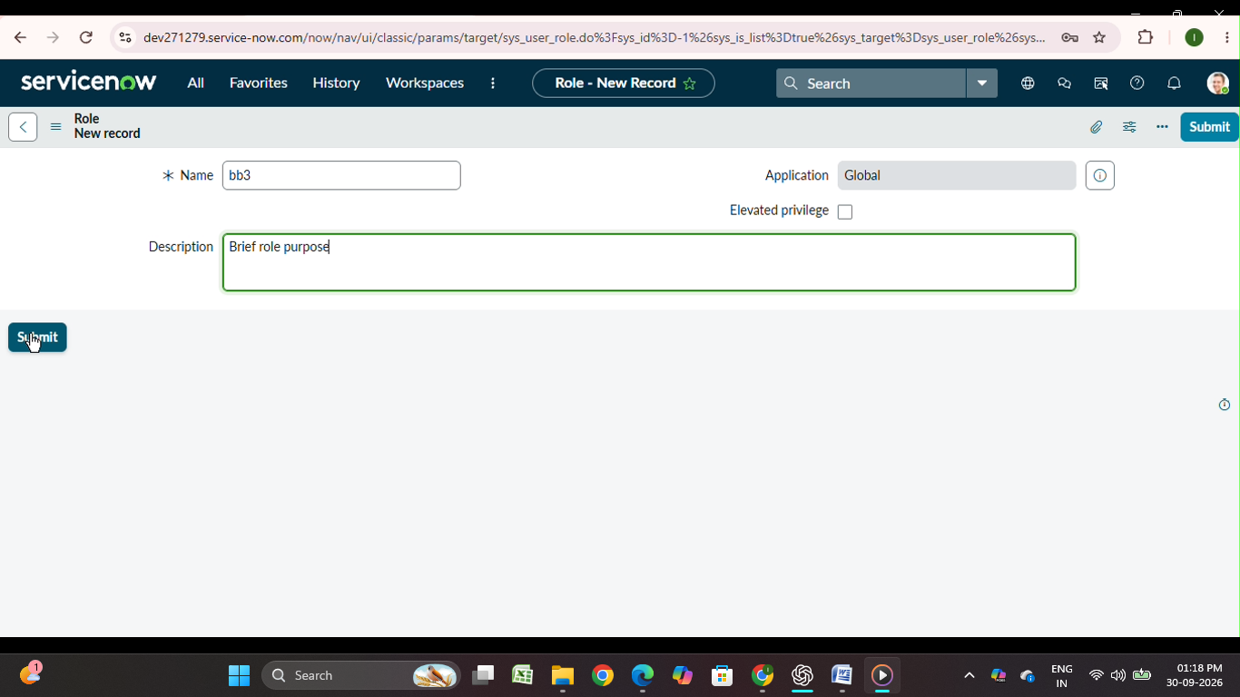

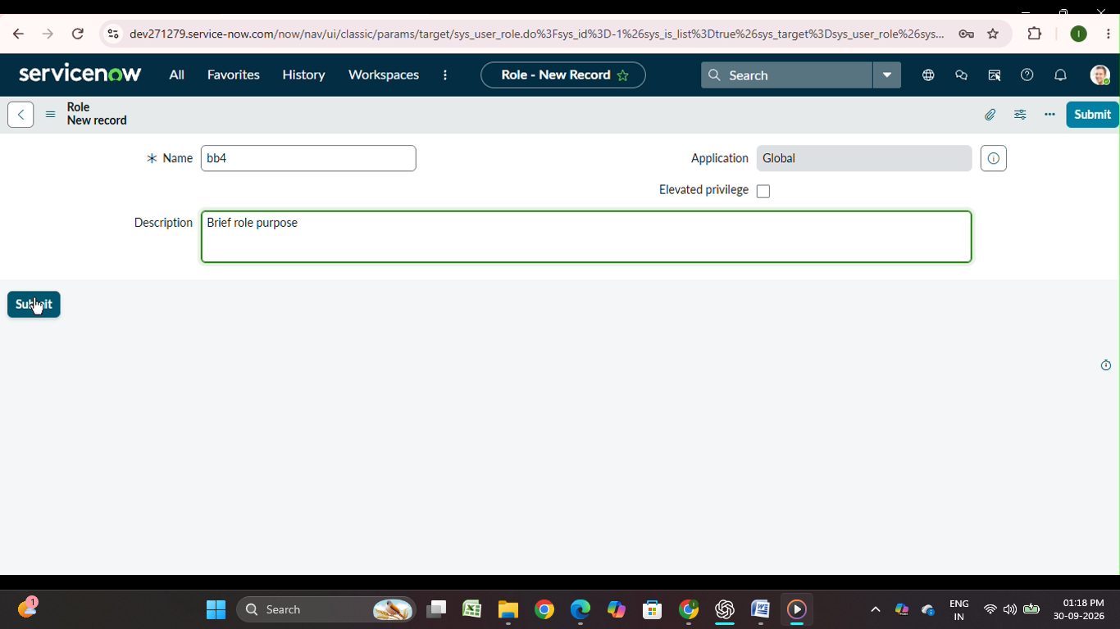

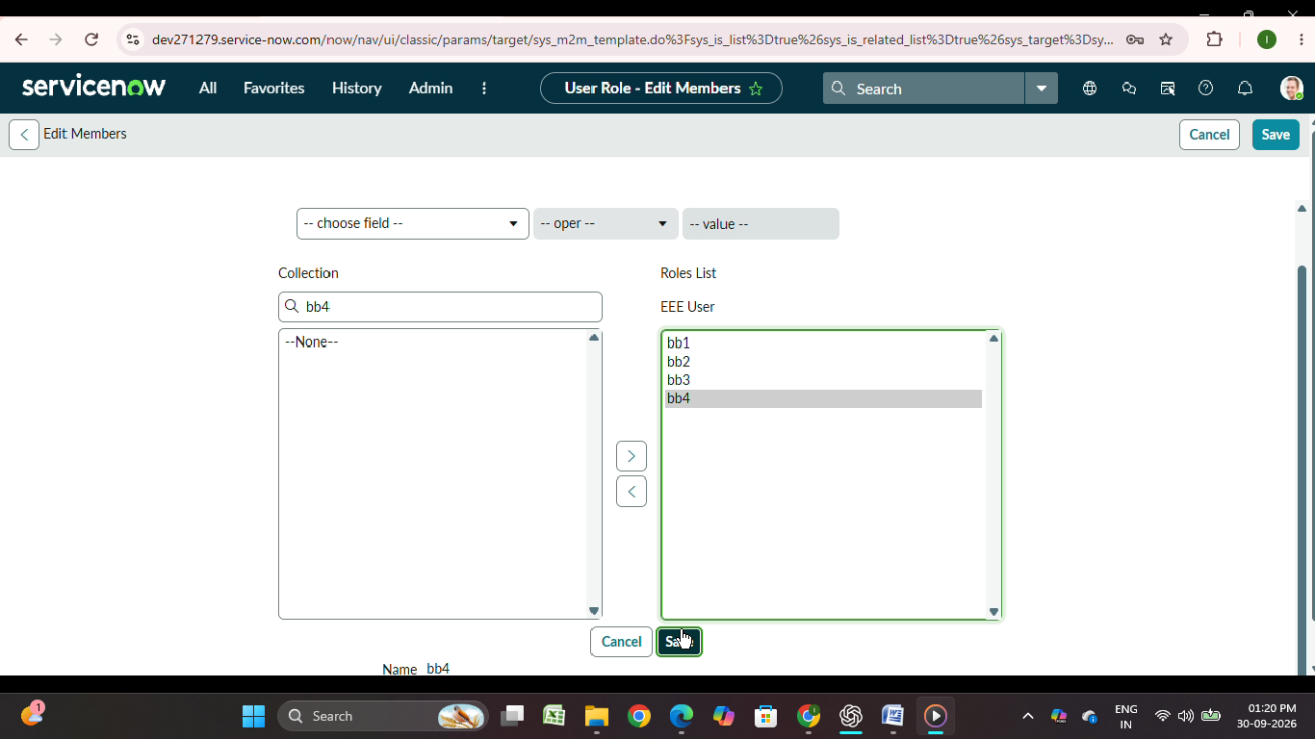

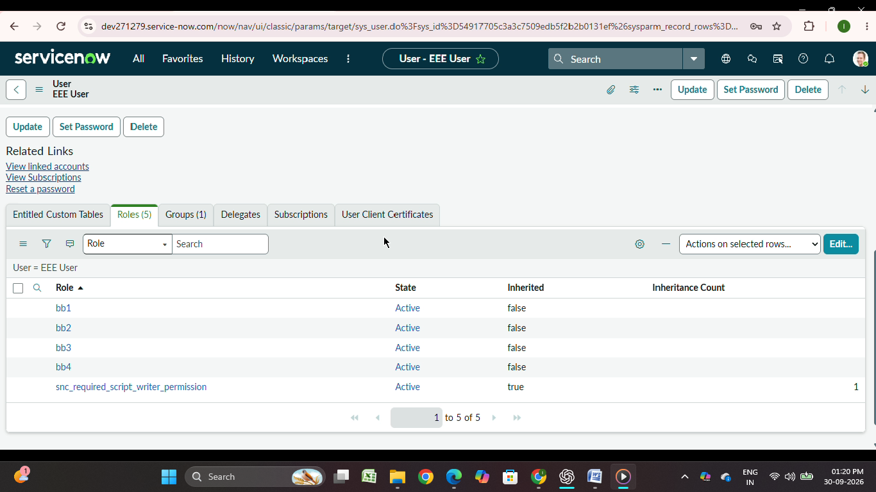

Output Screenshots of Milestone 2

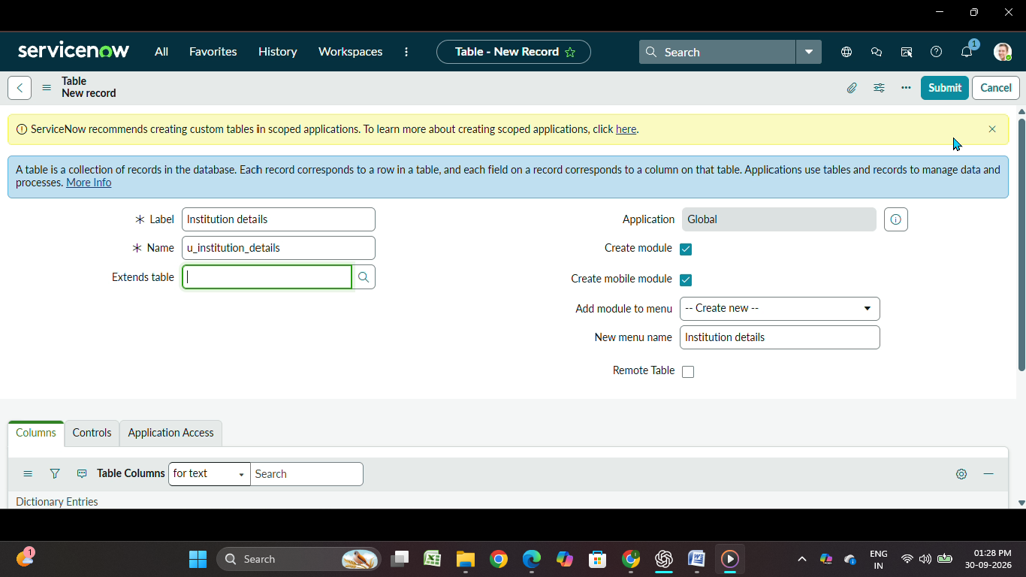

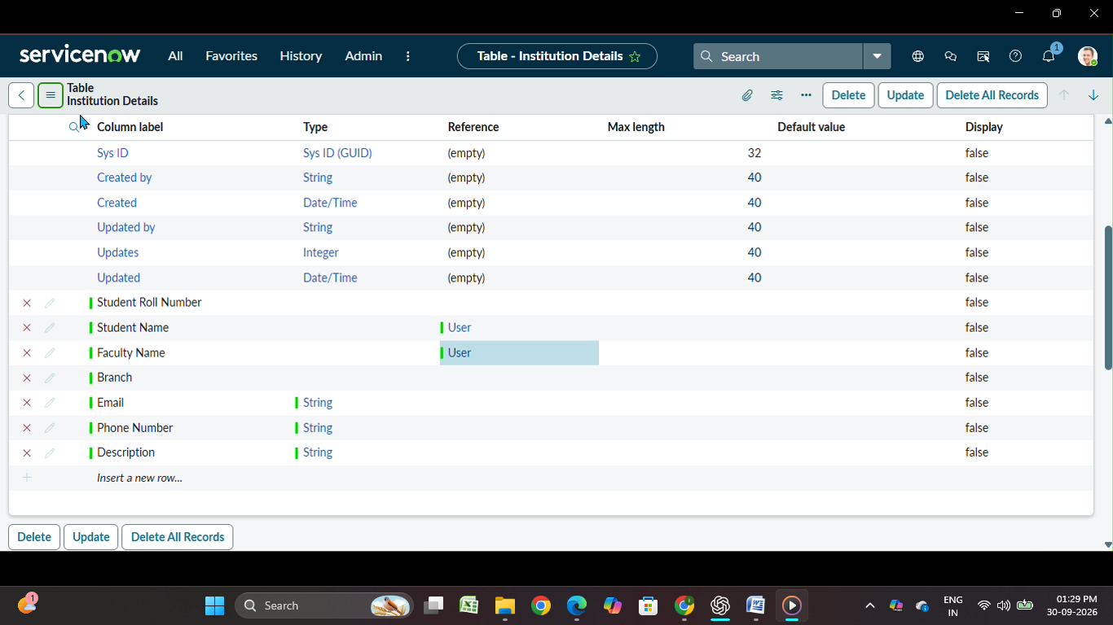

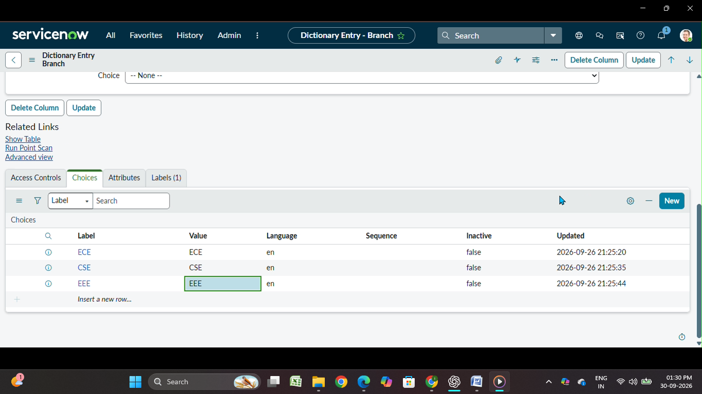

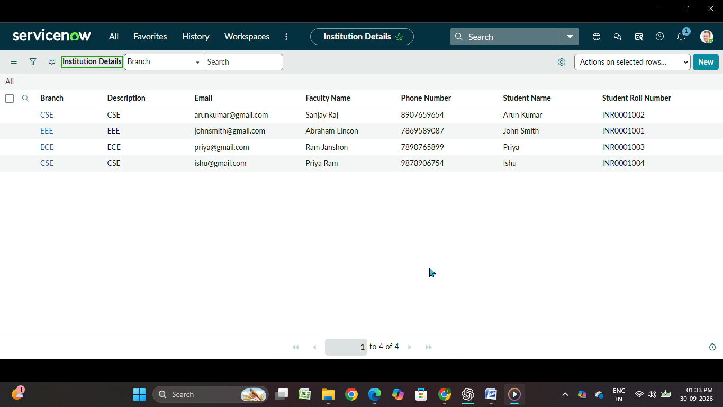

Output Screenshots of Milestone 3

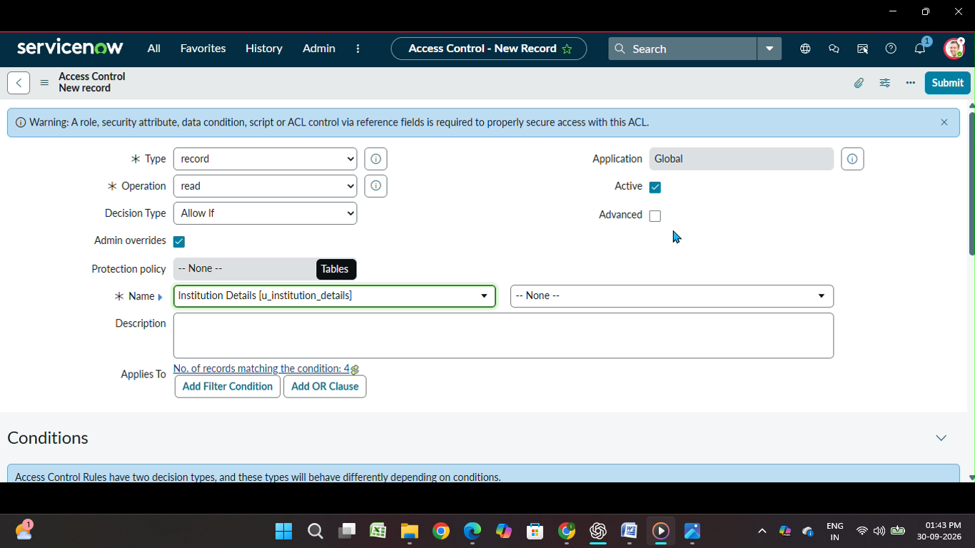

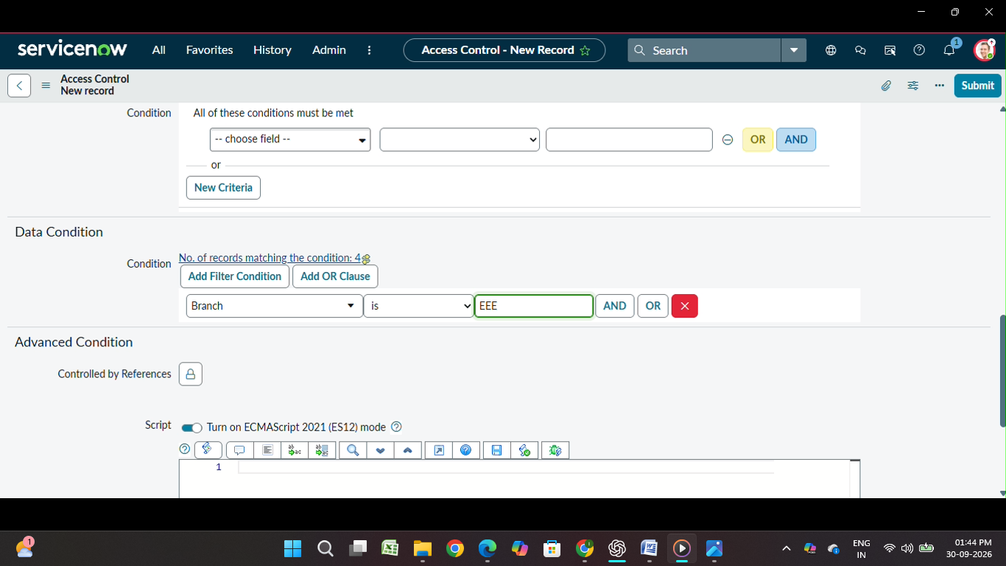

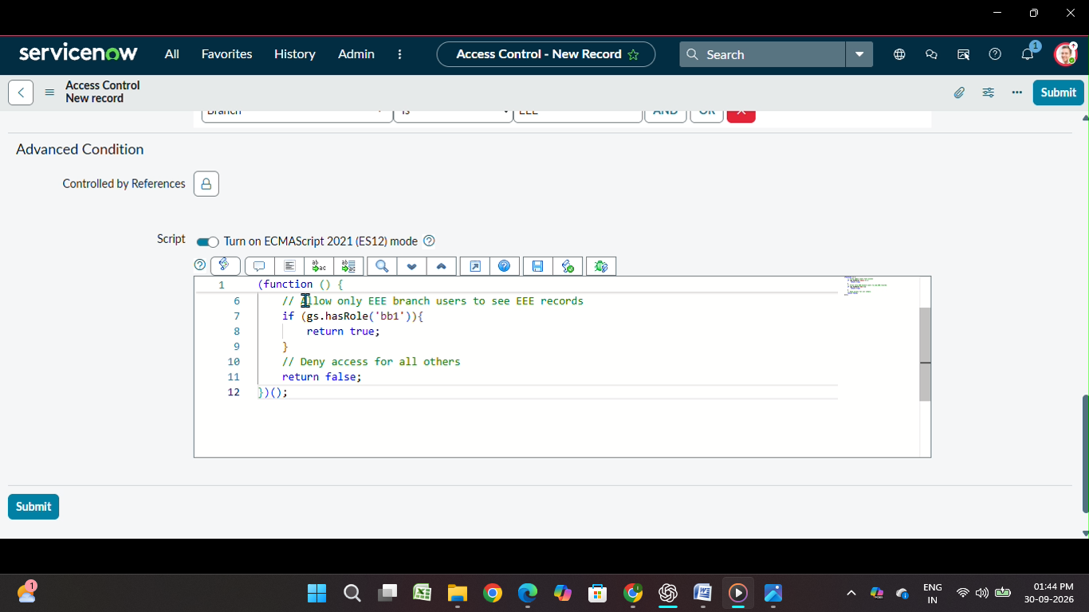

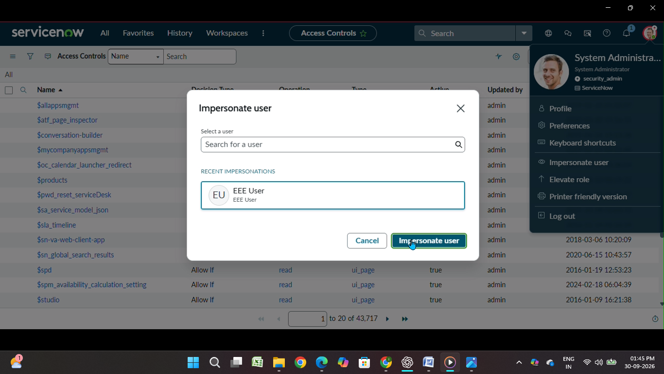

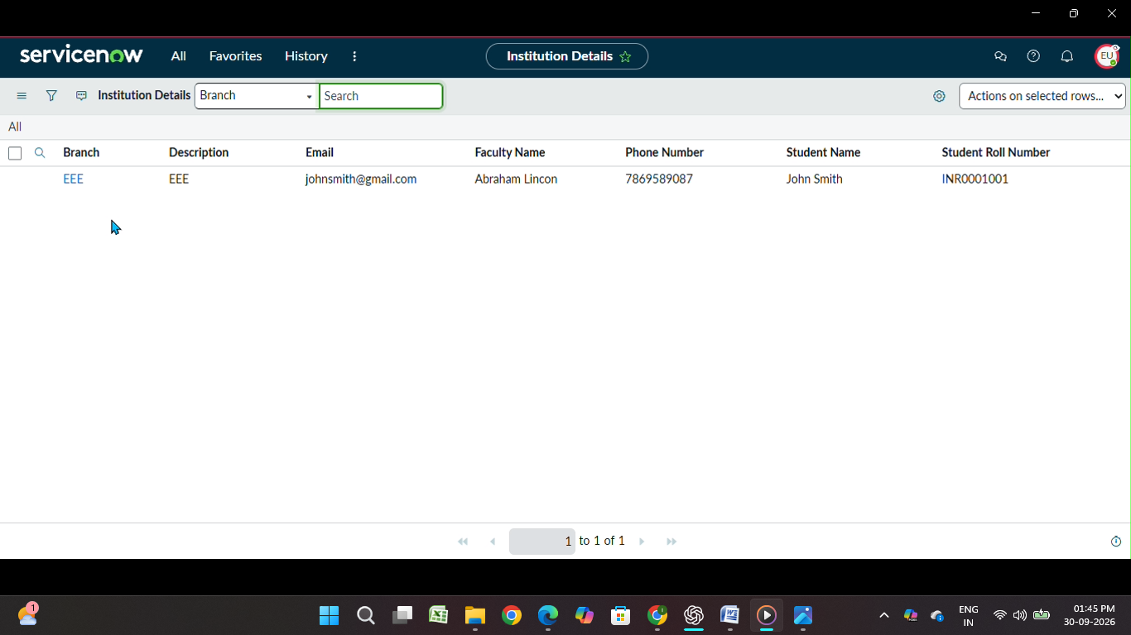

Output Screenshots of Milestone 4

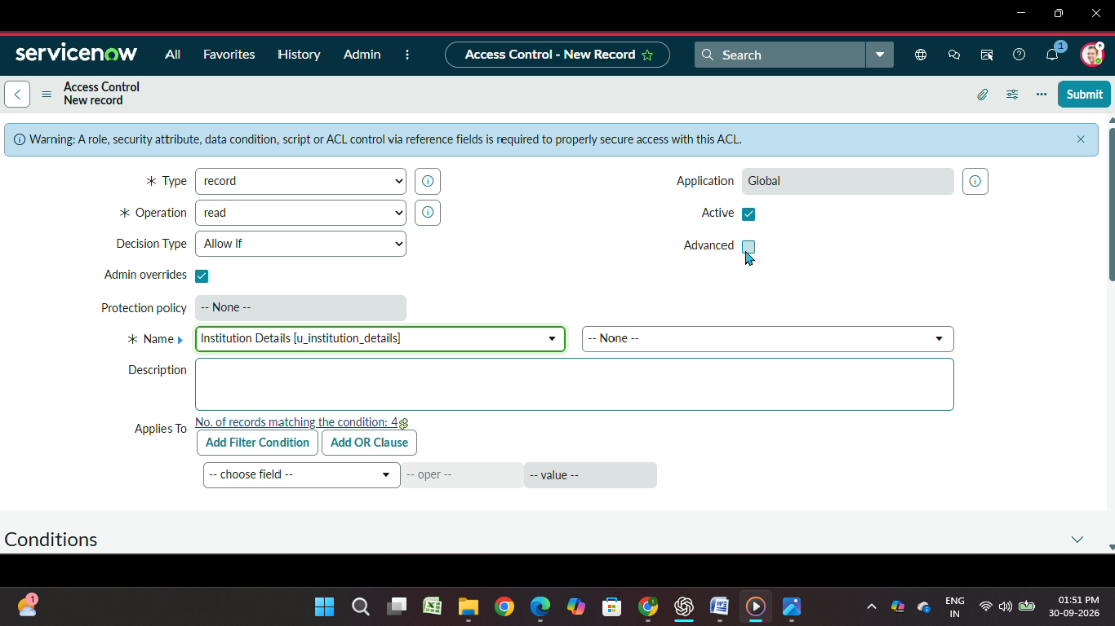

Output Screenshots of Milestone 5

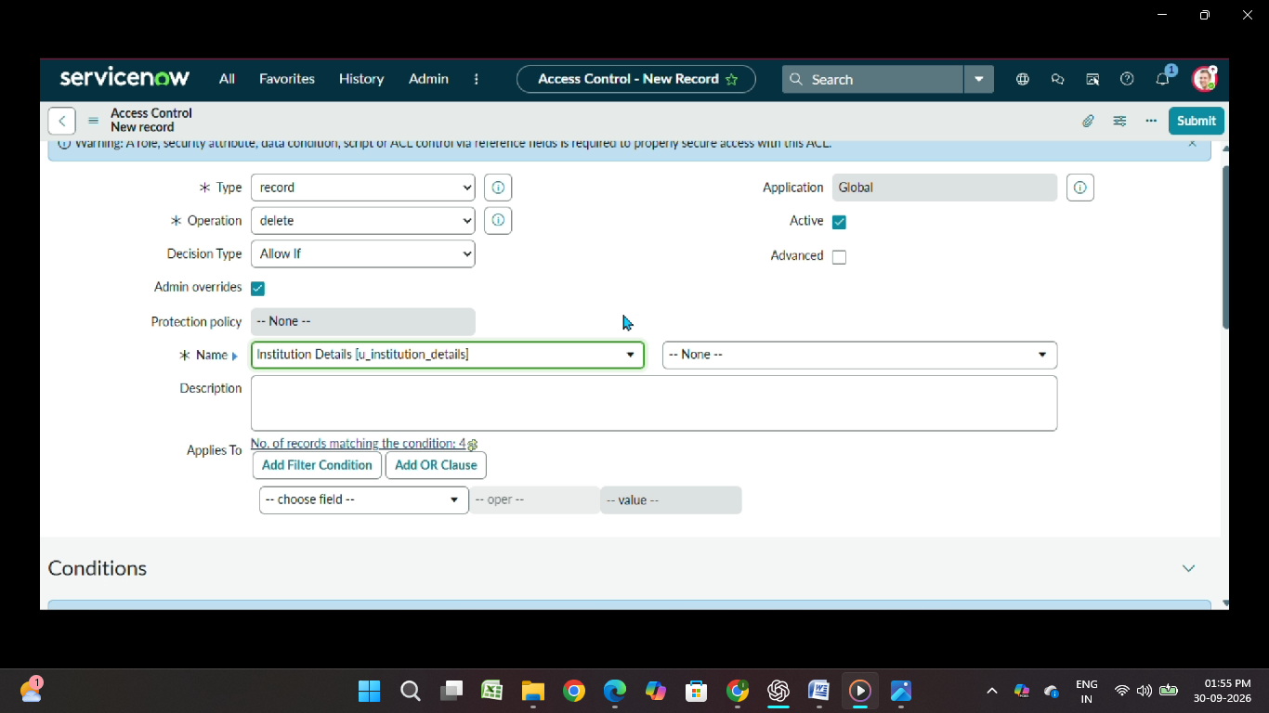

Output Screenshots of Milestone 6

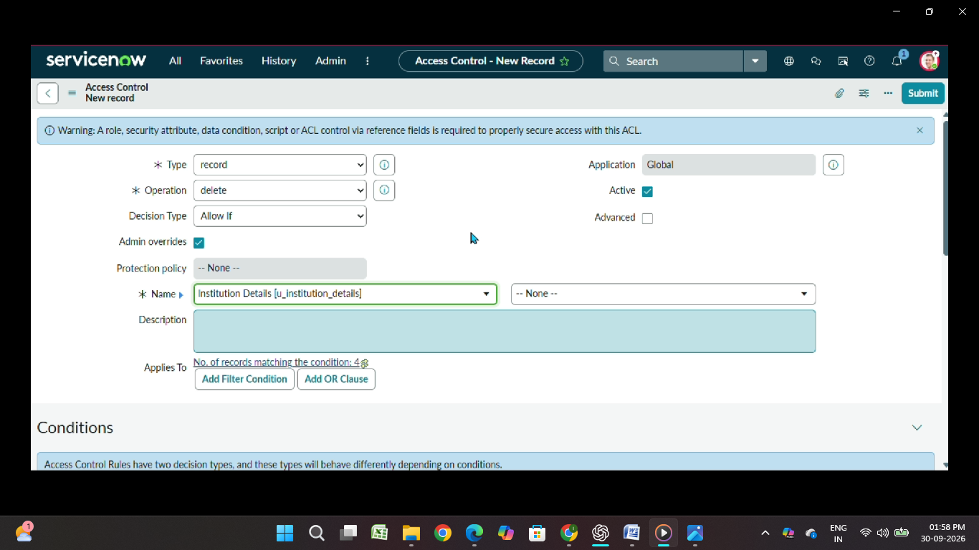

Output Screenshots of Milestone 7

8. ADVANTAGES & DISADVANTAGES

Advantages
- Provides record-level security.
- Restricts unauthorized users from viewing records.
- Supports role-based access control.
- Uses Branch values as an additional access condition.
- Separately controls Read, Create, Write and Delete operations.
- Provides administrators with full access.
- Helps protect sensitive records from unauthorized modification or deletion.

Disadvantages
- ACL configuration requires careful role and condition management.
- Incorrect ACL configuration can result in access being allowed or denied incorrectly.
- Multiple ACLs must be maintained for different operations.
- Testing is required whenever roles, conditions or ACL scripts are changed.

9. CONCLUSION
The Script-Controlled ACL – Restrict Record Access Based on Field Value project demonstrates how ServiceNow ACLs can be used to enforce record-level security.
The project combines user roles and record field values to control access. EEE branch users can access EEE records, while administrators retain full access. Separate ACLs are used to control Read, Create, Write and Delete operations.
The project provides practical understanding of how ACLs protect records from unauthorized viewing, creation, modification and deletion.

10. FUTURE SCOPE
The project can be extended by introducing additional branch-based access rules, more granular role permissions and additional conditions for different types of records.
Future enhancements can also include more detailed access reports, centralized ACL monitoring and additional record-level security conditions.

11. APPENDIX

Source Code
Included the final ACL script and ACL configuration details used in the ServiceNow project.
(function () {
if (gs.hasRole('admin')) {
return true;
}

if (gs.hasRole('bb1')) {
return true;
}

return false;
})();

Dataset Link
ServiceNow u_institution_details table.
Since this project uses custom ServiceNow records (ECE, EEE, CSE) rather than a separate public dataset, you can write:

GitHub & Project Demo Link
GitHub: Add project GitHub repository link here.
Project Demo: Add final project demonstration video/link here.

